*My Listing is the optimal business listing for businesses striving to get found*

*in local searches because it is rich with information and optimized for mobile.*

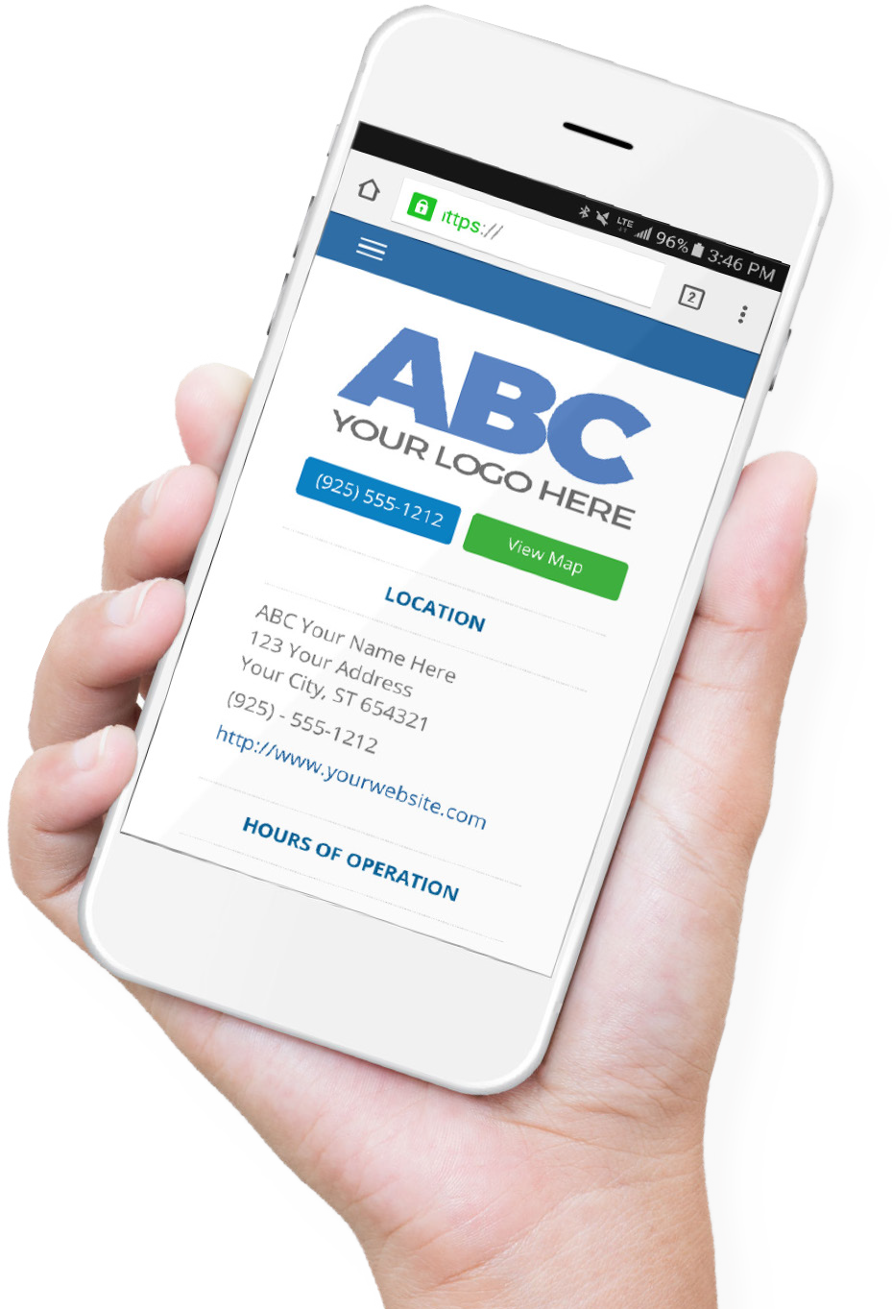

**MY LISTING**

Easily build a mobile-optimized business listing that gets found on Google.

**Drive traffic to your business**

It’s important to get on the first page of Google search results. Doing so leads to more traffic, and more traffic leads to more sales. But, faced with complicated search algorithms, it’s tough to get there.

My Listing is an information-rich business listing that helps your business get

found. With a mobile-optimized design and well-written code (structured data markup), we’ve built these listings to get you found in local searches and drive traffic to your business.

**Optimized for local search**

Search engines like Google use complex algorithms to find and organize their data. We’ve built My Listing in a way that follows the high standards outlined by Google. That way, your business listing is much more likely to get found in local searches.

**Designed for mobile devices**

Consumers search for local businesses more often on mobile than on desktop. As such, search engines heavily favor mobile-optimized sites.

My Listing offers:

* A responsive design that looks great regardless of screen size.
* Finger-friendly buttons that make it easy for consumers to contact or visit your business.
* Quick page load times for mobile devices.

**MY LISTING**

**What is a business listing?**

A business listing is an online profile that contains information about your business (like the Yellow Pages). Consumers can discover these profiles on sites like Google and Facebook, and then use them to learn more about your business.

logo here

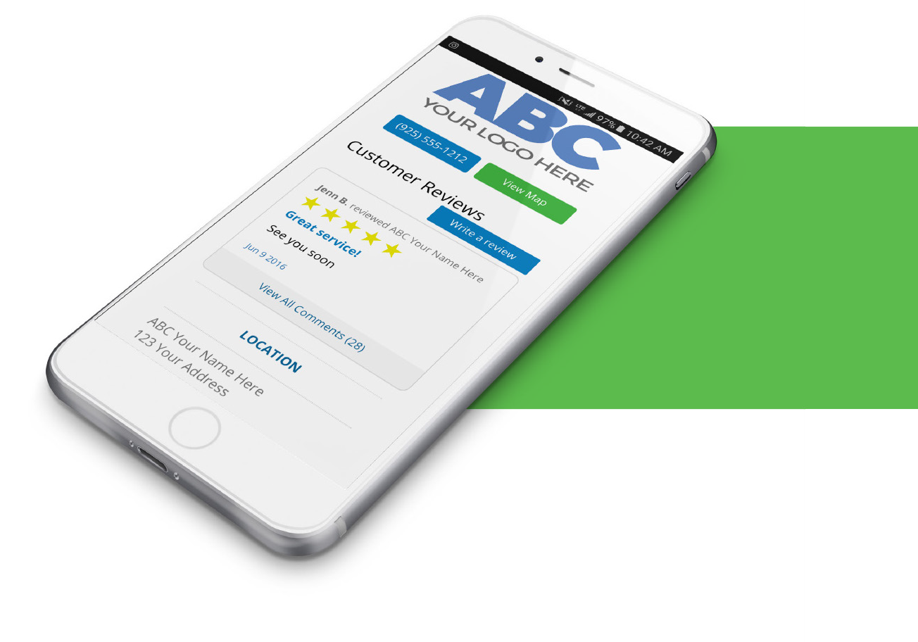

**MY LISTING**

Easily build a mobile-optimized business listing that gets found on Google.

With My Listing, you can easily build an information-rich

business listing that includes:

* Photos
* Videos
* Custom pages
* Contact info
* Customer reviews
* Coupons

This unique listing also allows you to use your own

branding, customize your domain (URL), track your marketing campaigns and monitor site analytics.

**Name**

Position

Company

Office Phone: Cell Phone: Linked In:

Email | Website

**MY LISTING**

insert photo here

**Integrated with our other products**

My Listing is seamlessly integrated with other products within our product suite. This integration gives you more control over your online reputation.

**Reputation Management:** Request, collect and respond to customer reviews. Customer reviews will help you build trust and credibility, and improve the chances consumers choose you over your competition.

**Social Marketing:** Efficiently share your coupons with existing customers and potential leads through your social media pages.

logo here